

Mechanical Engineering Department.

**Computer Project Number 3**

ME 554 Finite Element Analysis. Spring 2018

Instructor: Dr. Heidi Feigenbaum

Teaching Assistant: Dylan McAdams

Diego Ruiz

**Project Descriptions**

This project is concerned with design of a bicycle frame using aluminum tubes. The schematic dimensions of the bicycle are shown in Figure 4.24. The following two load cases should be considered.

(a) Vertical loads: When an adult rides the bike, the nominal load is estimated as a downward load of 900N at the seat position and a load of 300N at the pedal crank location. When a dynamic environment is simulated using the static analysis, the static loads are often multiplied by a dynamic load factor G. In this design project, use G = 2. Use ball-joint boundary conditions for the front dropout (location 1) and sliding boundary conditions for the rear dropouts (locations

5 and 6).

(b) Horizontal impact: The frame should be able to withstand a horizontal load of 1,000N applied to the front dropout with rear dropouts constrained from any translational motion. For this load case, assume the front dropout can only move in the horizontal direction. Use G = 2.

Choose aluminum tubes of various diameters for the various members of the frame shown in Figure 1 such that the bicycle is as light as possible. The minimum outside diameter is 12mm and the wall thickness is 2 mm. Approximate the frame as a plane frame by giving the same (x, y) coordinates for Nodes 5 and 6. Thus, all the nodes will be on the x-y plane. In addition to the dynamic load factor, use a safety factor of 1.5. Use von Mises failure stress criterion for yielding. For compression members, include buckling as additional criterion. The buckling load of a member is approximated as $P_{cr}= 2π^{2}EI/L^{2}$ where L is the member length. Use a safety factor of 1.5 for buckling also.

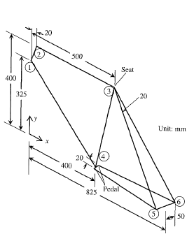

Figure 1

**Introduction**

In the pursuit of learning how FEA solves frame problems, we are asked to solve a bike frame with point loads. This problem will be solved with FEA methods for two different loading cases shown in figure 1 and 2, respectively by implementation in ANSYS. After our first design is complete, we are asked to optimize the frame by adding two more designs with different dimensional conditions.. Finally, we are going to evaluate two main parameters (Maximum Von-Mises stress and Buckling load) in order to approve our designs.

**Model Development**

Assumptions:

* The material is consider isotropic.
* 2-D problem deformations.
* Linear elastic material behavior.
* Plane sections remain plane and perpendicular to the neutral axis.
* Small deformations and small rotations.
* Element behavior 🡪 Cubic
* Pipe 2 node 288
* The applied forces have been multiplied by the dynamic factor (2).

CASE 1

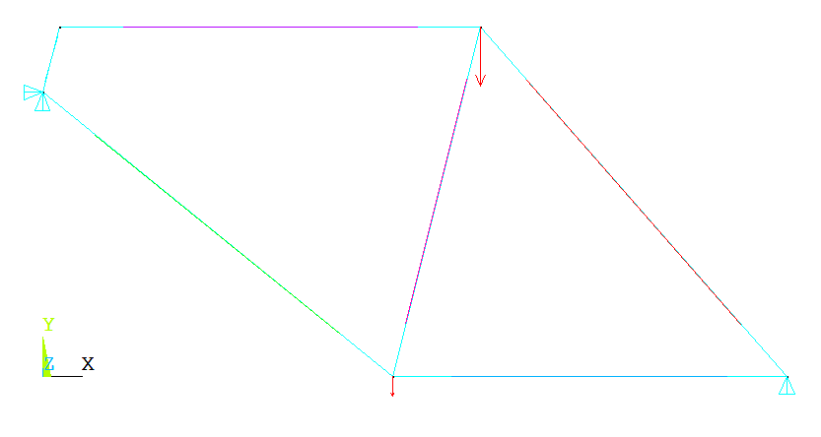 Figure 2

Forces have been multiplied by the dynamic factor (2).

600 N

1800 N

CASE 2

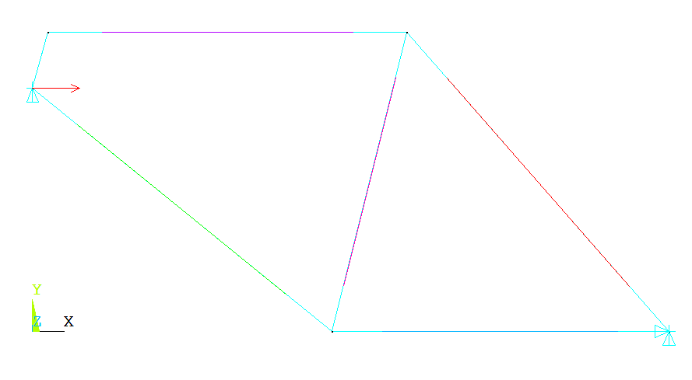

2000 N

Figure 3

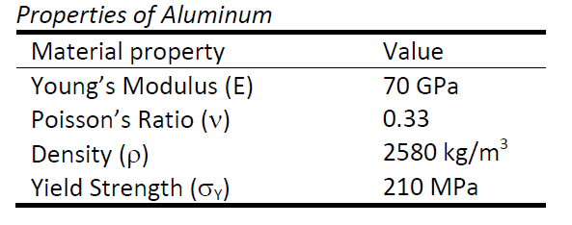

Table 1

I used the above properties for all my designs.

First Design

Pipe diameter 15 mm

Wall thickness 2 mm

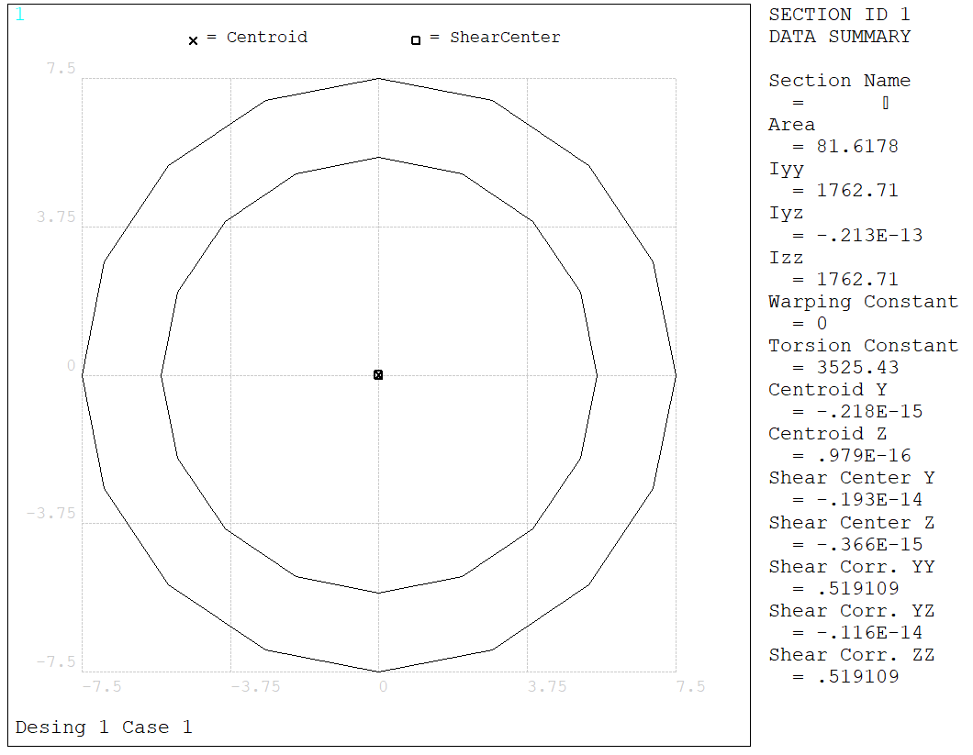

Figure 4

Second Design

Pipe diameter 12mm

Wall thickness 2 mm

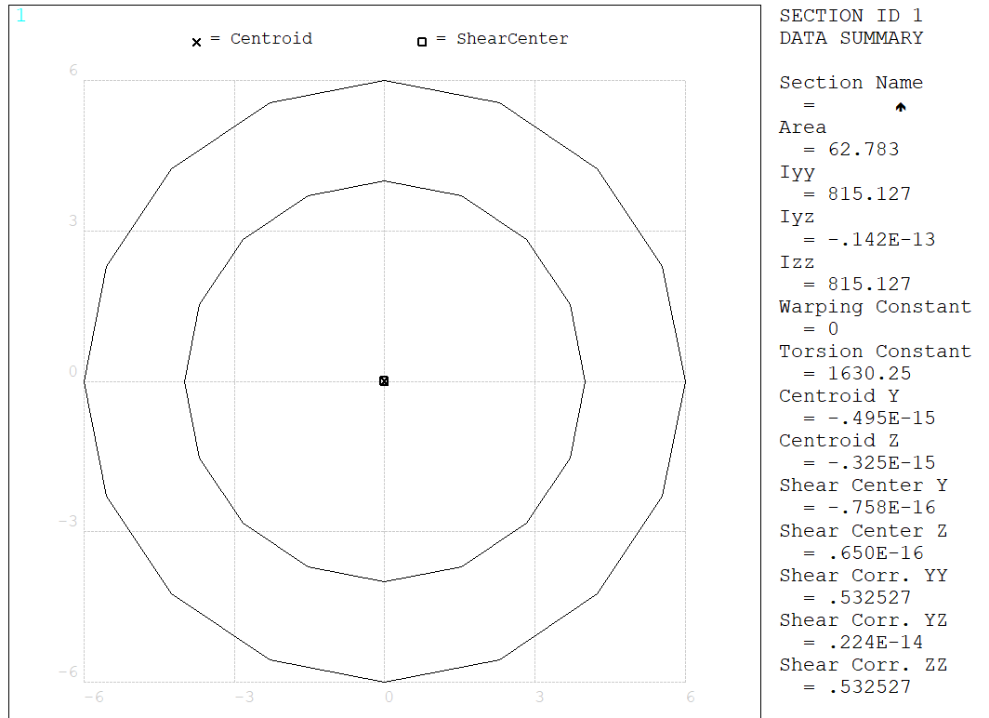

Figure 5

After simulating, I remembered that the minimum wall thickness is 2 mm, so this design is quantitatively wrong but qualitatively right

Third Design

Pipe diameter 14mm

Wall thickness 1 mm

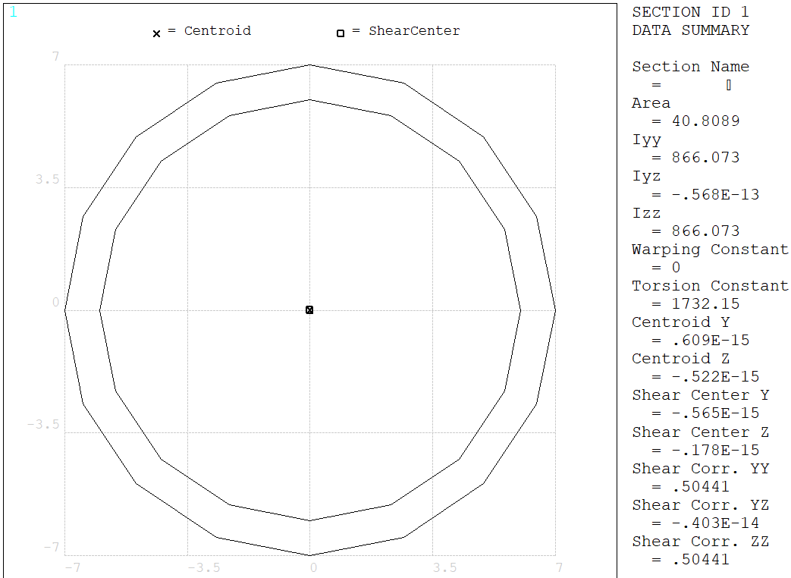

Figure 6

|  |  |
| --- | --- |
| **1 to 2 (mm)** | 77.62 |
| **1 to 4 (mm)** | 515.38 |
| **4 to 5 (mm)** | 425 |
| **3 to 5 (mm)** | 583.63 |
| **2 to 3 (mm)** | 500 |
| **3 to 4 (mm)** | 412.31 |
| **Total legth (mm)** | 2513.94 |

Table 2

|  |  |
| --- | --- |
| **Profile** | **Total Weight (kg)** |
| 15 x 2 | 0.529 |
| 12 x 2 | 0.407 |
| 14 x 1 | 0.26 |

Table 3

Note that the indicated nodes here are the ones given by the book problem.

For the total weight, we need to take into consideration that a 2-D problem assumption was made and only elements in the shown plane have been taking to calculate the total weight.

**Results**

Deformation Shape

Design 1 CASE 1

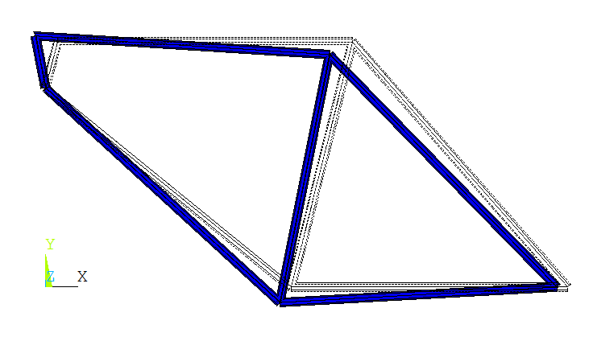

Figure 7

Design 1 CASE 2

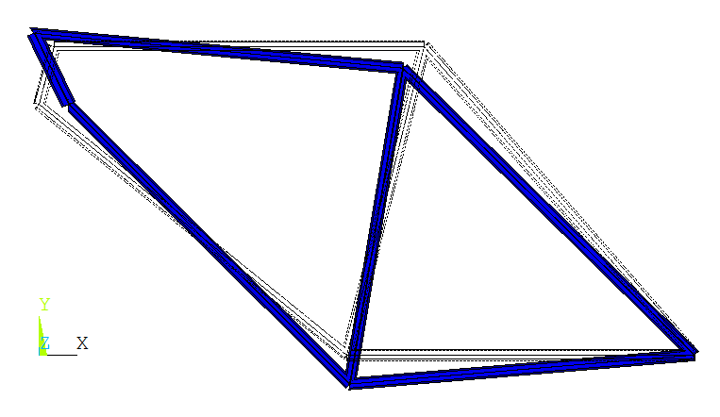

Figure 8

Figure 7 shows how the frame deforms at it was expected according to the applied loads and boundary conditions.

Maximum stress value and location

Design 1 CASE 1

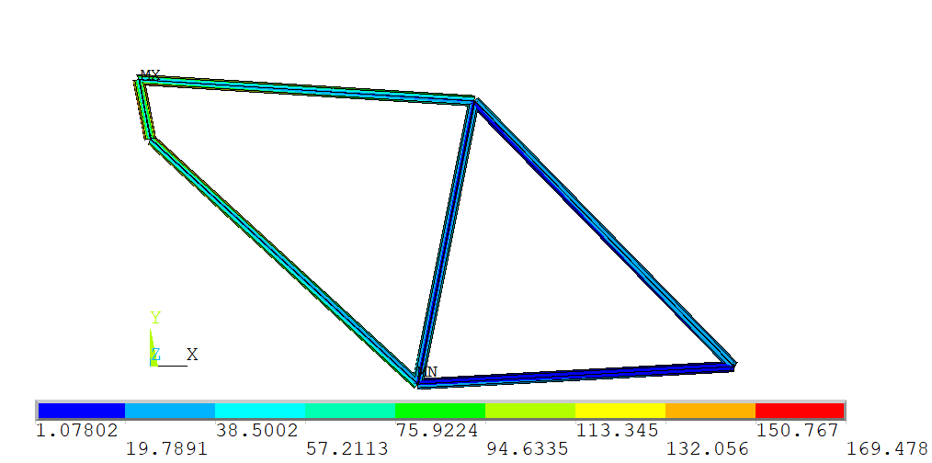

The maximum stress is found in this zone

Figure 9

Design 1 CASE 2

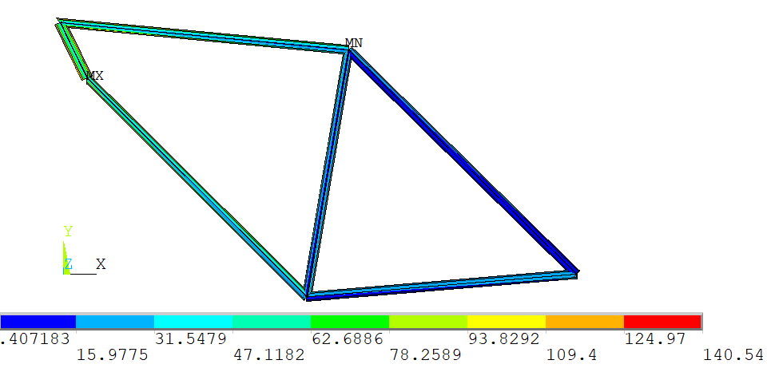

The maximum stress is found in this zone

Figure 10

Maximum stress is presented always at the same location in both cases. However, the magnitude of the second case is 18 % less than the vertical loads case. This could be explained by the degrees of freedom that has been set in that node.

|  |  |  |  |  |  |  |
| --- | --- | --- | --- | --- | --- | --- |
|  | Desing 1   CASE 1 | Desing 1   CASE 2 | Desing 2   CASE 1 | Desing 2   CASE 2 | Desing 3   CASE 1 | Desing 3   CASE 2 |
| Von-Mises (MPa) | 169.48 | 140.54 | 288.067 | 234.87 | 323.17 | 268.74 |
| Factor of Safety | 1.24 | 1.49 | 0.73 | 0.89 | 0.65 | 0.78 |

Table 4

Note that the results highlighted in green are those that pass with a safety factor higher than 1. For these tests, only the design 1 meet the mechanical requirement of maximum stress. The rest of them will fail under these conditions. In addition, I want to point out that for the design 3 (case 1) the safety factor is the lowest one under these conditions.

Buckling

The load of buckling has been calculated by funding the axial loads in the elements as is shown in the element table below (Figure 11).



Figure 11

In the following figures (12 & 13), it can be seen the most potential bars to be buckled. In 12, rear element (3-5) present the highest compression value, as it does the bars (1-4) and (4-5). These are the bars that are going to be studied for buckling.

Design 1 CASE 1

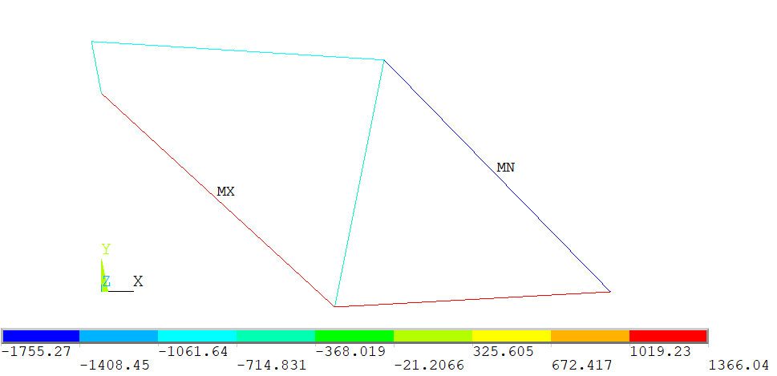 Figure 12

Potential Buckling will be happening here

Design 1 CASE 2

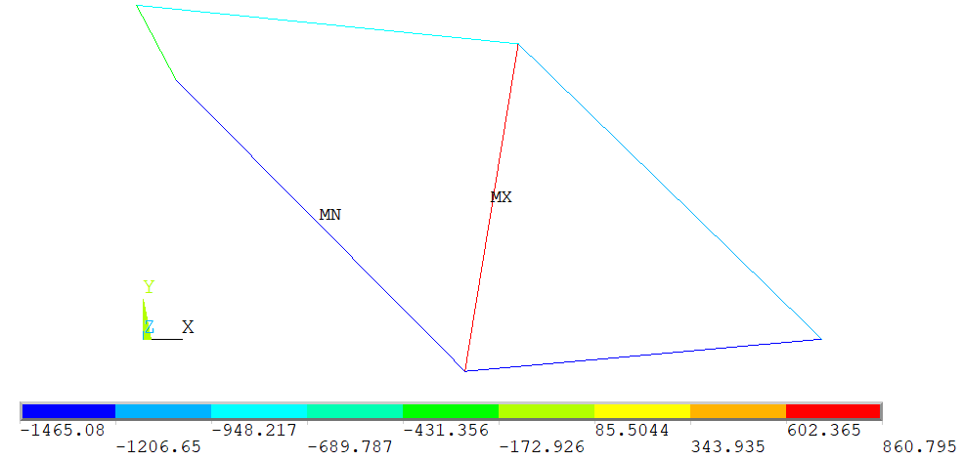 Figure 13

Potential Buckling will be happening here

|  |  |  |  |  |
| --- | --- | --- | --- | --- |
|  |  | Outside  Diameter (mm) | Inside  Diameter  (mm) | Wall  Thickness  (mm) |
| Moment of Inertia (1) | 1766.36 | 15 | 2 | 11 |
| Moment of Inertia (2) | 816.81 | 12 | 2 | 8 |
| Moment of Inertia (3) | 867.86 | 14 | 1 | 12 |
|  |  |  | Safety Factor 1  (1-4) | Safety Factor 2  (4-5) | Safety Factor 2  (3-5) |
| P_cr (N) Desing 1 CASE 1 | 7165.26 |  |  |  | 4.08 |
| P_cr (N) Desing 1 CASE 2 | 9188.66 | 13512.30 | 6.27 | 9.22 |  |
| P_cr (N) Desing 2 CASE 1 | 3313.41 |  |  |  | 1.89 |
| P_cr (N) Desing 2 CASE 2 | 4249.09 | 6248.46 | 2.90 | 4.26 |  |
| P_cr (N) Desing 3 CASE 1 | 4514.66 |  |  |  | 2.57 |
| P_cr (N) Desing 3 CASE 2 | 3520.50 | 6638.99 | 2.40 | 4.53 |  |

Table 5

As we can see above (Table 5) all the designs fulfill the mechanical requirements for buckling.

**Discussion**

All results presented in the previous section match with expectations. As we can see in the deformation results, the simulation results match with what we have expected for the two independent cases. Additionally, the maximum stress for the case 1 it is found in the front drop-out, as well as in the case 2. For this second case, I am a bit skeptical about the Von-Mises stress being the maximum at that location. Finally, I would like to highlight the fact, that the second cases is a more critical case than the first one.

For convenience, FEA is recommended for these types of problems. The complexity of the problem does not reach an extreme level. Some other methods can be applied to solve these type of structures as Hardy Cross method, but it will be very time consuming.

The best design in this project is the design number 1 because meets the requirements. However, I think this design is oversized and a more efficient design can be found.

The used material is aluminum because it is an affordable material with great mechanical properties. Other materials can be found for this type of applications such as carbon fiber; however, the price is very high.

Other tests must be done on these type of frames before they are manufactured, some of them are:

1. Fatigue test. (For testing the life time of the frame)
2. Case 1 and case 2 in a dynamic test.
3. Testing the maximum bending moment under different loads.
4. Welding analysis. (To identify micro-fissures )
5. Quick impacts.

Finite element analysis give us a good approximation of the problem in a very short time. This is the main motive why FEA is used for engineering design. Results can be reached and checked without an excessive consumption of time. This allows us to iterate the results and change the design till converging with a very efficient final design. However, the results of this simulation are not exact. For exact results we will need to refine the mesh to the point that simulations can take a long time to solve the problem.

**Conclusion**

Once again the finite element analysis of this problem is not a strict requirement; however, it will be more than helpful the use of a FEA software to analyze the problem, even though it could be calculated by mechanics of material, it will be tremendously tedious and tricky.

The more number of elements the better approximation we obtain.

In essence, we could say that FEA methods are very recommended for this problem.